Act Report WeRateDogs
Most popular names
After the data cleaning of the dog names, all existing names are filled in the name column of the
merged archive table. The most popular dog names are the following:
Name, Name count:
Charlie 13
Oliver 11
Cooper 10
Lucy 9
Tucker 9

most people using Twitter for iPhone

Dogs in Pupper stage of dog life cycle get most tweets, which is expected.
The most popular dog type is “Pupper” with a count of 201. I think “Pupper” is the most common dog
type in the tweet data, as Puppers are small dogs and they don’t need a lot of space to be happy.
Discover the ratio of dog rating distribution:
Here after we calculated the ratio of dog rating from(rating numerator /rating denominator)rate, we can see
- that the chart takes normally distribution of dogs rating.
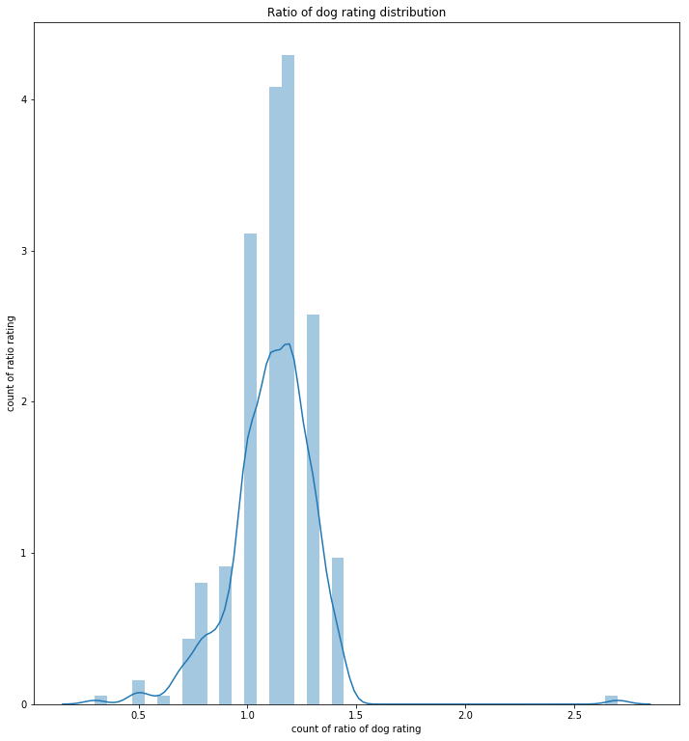
The most common dog name is Cooper
